High-performance computing system

Requirements document

Jelle Maas (479146)

Koen Janssen (451394)



# Contents

**Contents** **2**

**Version History** **3**

**1 Introduction** **4**

**2 Survey** **5**

2.1 Conclusion 7

3 Requirements **8**

3.1 Functional 8

3.2 Non-functional 9

**Conclusion** **10**

**Glossary** **11**

# Version History

| Date | Version | Author | Comment |
| --- | --- | --- | --- |
| 15.02.2022 | 0.1 | K. Janssen & J. Maas | Initial setup |
| 17.02.2022 | 0.2 | K. Janssen & J. Maas | Added non-functional and functional requirements based on survey results |
| 21.02.2022 | 0.3 | J. Maas | Added the front page |
| 12.03.2022 | 0.4 | N. Geilen | Improving requirements |

# 1 Introduction

Soon the students from Delta will have their own high powered computer, also known as the number cruncher. The goal of the number cruncher system is to give all Delta students the ability to easily send their resource-intensive workload, e.g. AI model training and media rendering, to this powerful computer. This could potentially save lots of time for the Delta students, for the number cruncher can do resource-intensive tasks much more efficiently.

The general idea is thus, to create an easy-to-use system for Delta students so they can submit their workloads to the number cruncher and finally get back their results. This while having a system that automatically manages the workloads on the infrastructure and software side.

# 2 Survey

For outlining the requirements for the system, there was a survey organised and shared with all the Delta students. The results shown below are not representative of Delta as a group, however, as of now, we didn't receive more survey submissions. The current results of the survey are below:

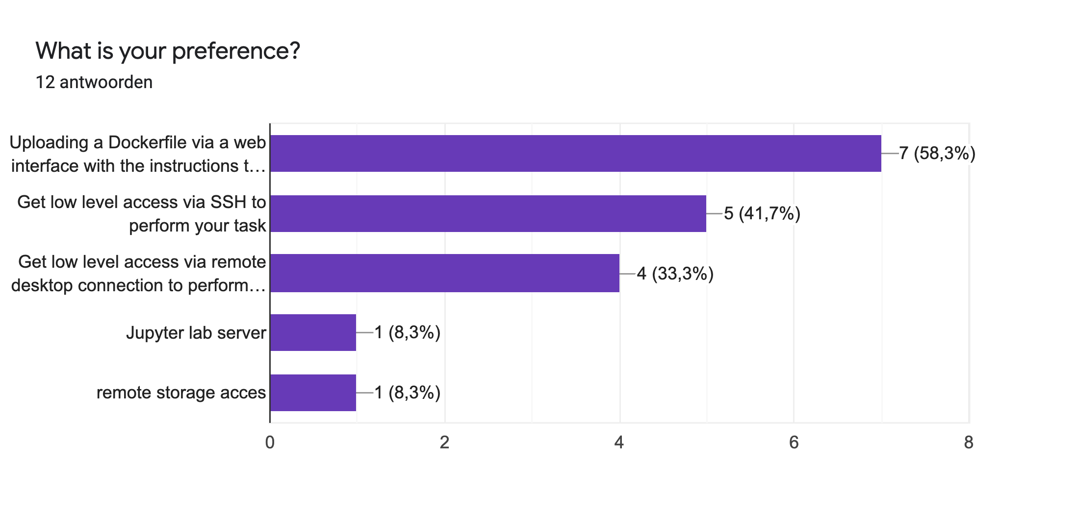

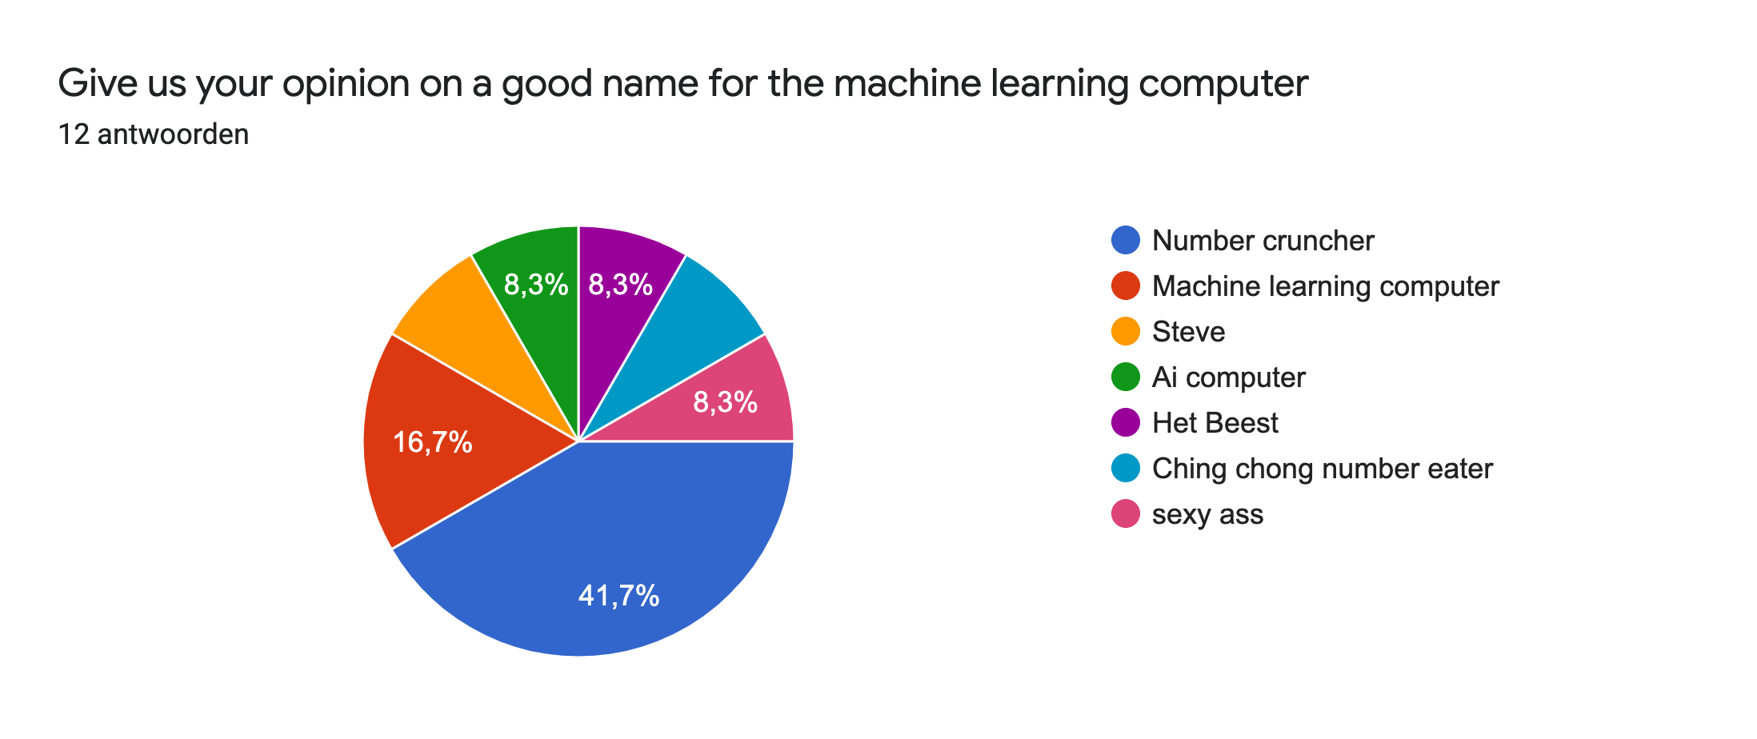

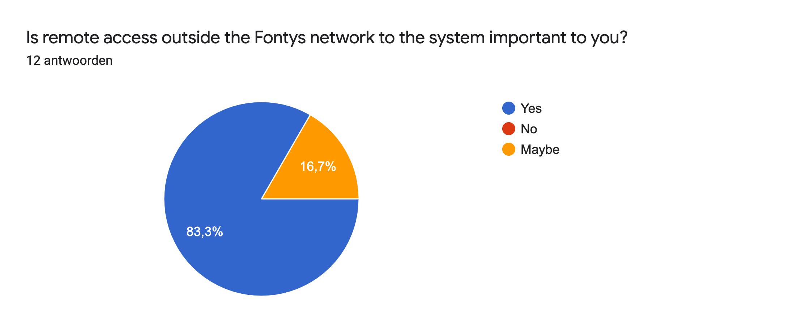

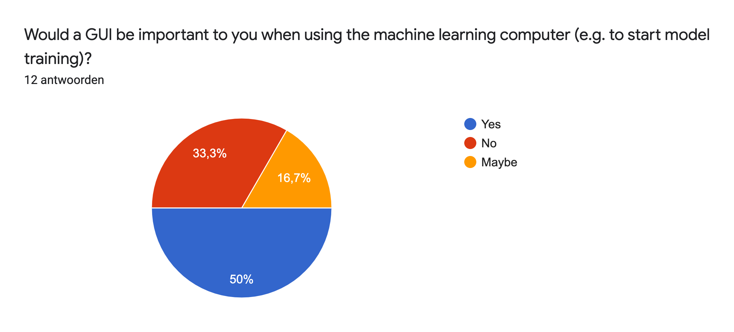

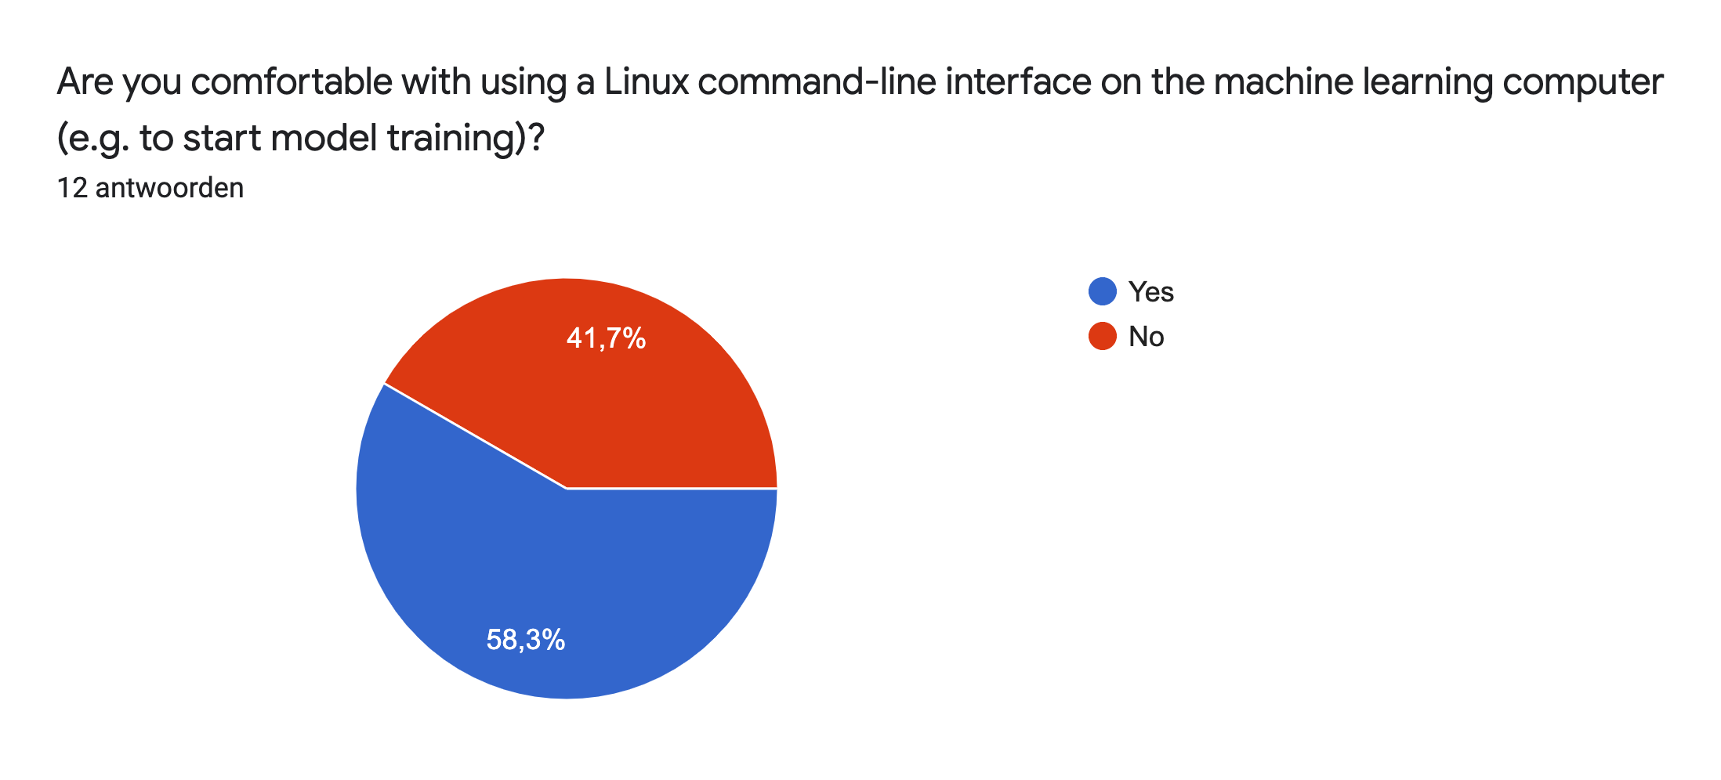

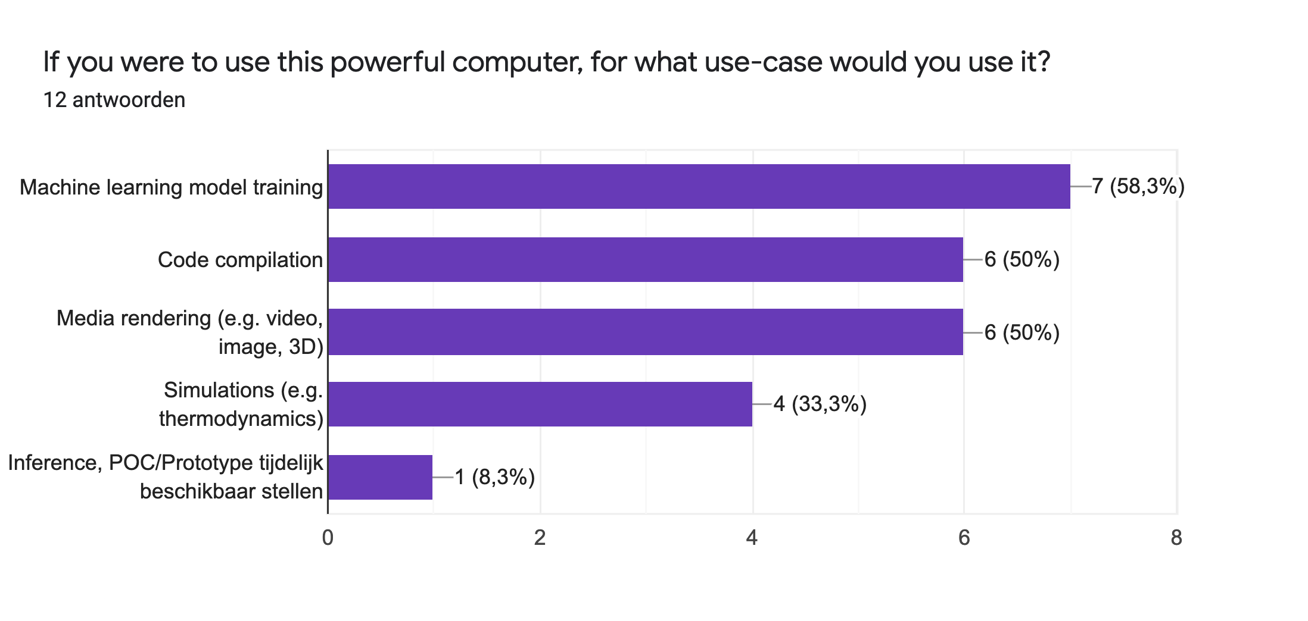

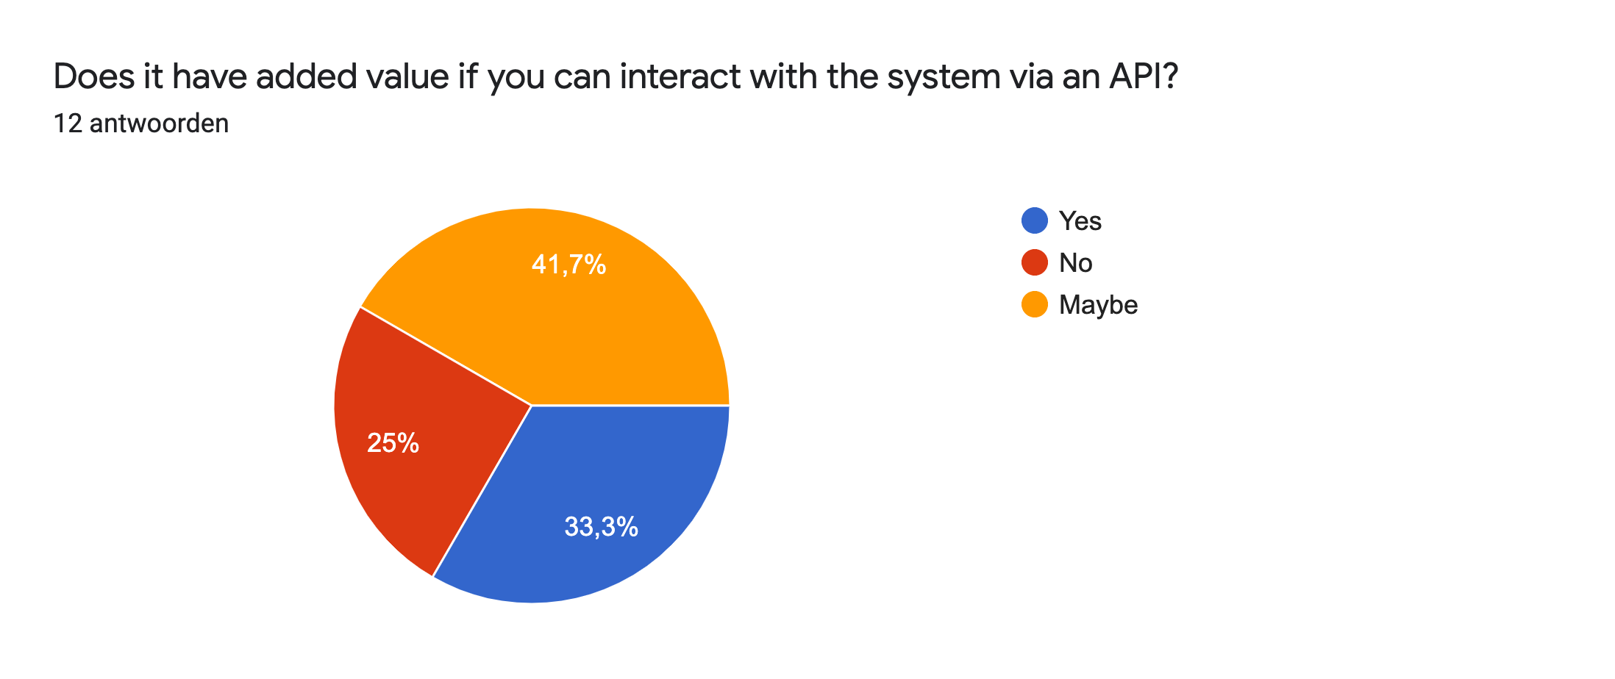

## 2.1 Conclusion

For polling necessary functionality and features, there was a survey organised among Delta students. However, due to a too low number of submitted surveys, the results are not representative of the Delta group as a whole. After a meeting with the stakeholder, it became clear that the defined scope during the conceptual phase was too stretched.

## 

# 3 Requirements

The requirements are prioritised using the MoSCoW method:

* **Must have:** These requirements must be returned, without these requirements, the product cannot be used.
* **Should have:** These requirements are highly desirable, but the product can be used without them.
* **Could have:** These requirements will not be addressed in this project but may be addressed in the future.
* **Will not/would not have:** These demands will not be processed.

## 3.1 Functional

The functional requirements are written down in the form of user stories. The user stories and acceptance criteria are described according to the following template:

* User Story: “As a <role>, I want <feature>, so I <value>.”
* Acceptance criteria: “Given <input situation>, when <event>, then <outcome>.”

| **ID** | **Priority** | **Description** |
| --- | --- | --- |
| FR-01 | Must | As a user, I want SSH access to my own environment on the system.   * AC-1.1 **Given**, I am a user **and** my public SSH key is registered **and** a personal environment is present **then** I can access my environment with SSH. |
| FR-02 | Should | As a user, I want to be able to connect a remote desktop application to my environment on the system   * AC-2.1 **Given**, I am a user **and** I have my own environment on the system. **then** I can connect to my environment with a remote desktop application. |
| FR-03 | Must | As an administrator, I want to be able to put the system in a maintenance state on-premise and remotely.   * AC-3.1 **Given,** I am an administrator **and** I need to do maintenance to the system **then** I can note on the web application that the system is in maintenance. * AC-3.2 **Given**, I am a user **and** it's noted that the system is in maintenance **then** I cannot connect to my environment over SSH or with the remote desktop application. |
| FR-04 | Should | As a user, I want to be able to create my own environment without interference from an administrator   * AC-5.1 **Given** I am a user **then**  I want to create my environment without the help of others. |
| FR-05 | Could | As an administrator, I want to be able to control the complete system and all of its environments via a web application   * AC-4.1 **Given** I am an administrator **then** I want full control and overview of the system via a web application. |
| FR-06 | Could | As a user, I want to be able to define the operating system of my environment.   * AC-6.1  **Given,** I am a User **and** I am in need of another environment than the default environment. **Then** I want to define my own environment with the help of an IOS file or software selection. |

## 3.2 Non-functional

| *ID* | *Priority* | *Name* |
| --- | --- | --- |
| NFR-01 | Should | The system should run optimally with minimal involvement from system administrators. |
| NFR-02 | Must | The system should be able to connect to the public internet. |
| NFR-03 | Must | The system is only accessible on-premise or via a VPN. |
| NFR-04 | Must | The system is only accessible to a whitelisted group of users, currently only Delta students. |

## 

# Conclusion

After a meeting with the stakeholder, it became clear that the defined scope during the conceptual phase was too stretched. Due to that, the group will work on redefining the requirements for the smaller scope.

# 

# Glossary

| *Term* | *Explanation* |
| --- | --- |
| AI | Artificial intelligence (AI) is intelligence demonstrated by machines, as opposed to the natural intelligence displayed by animals including humans. |

## 